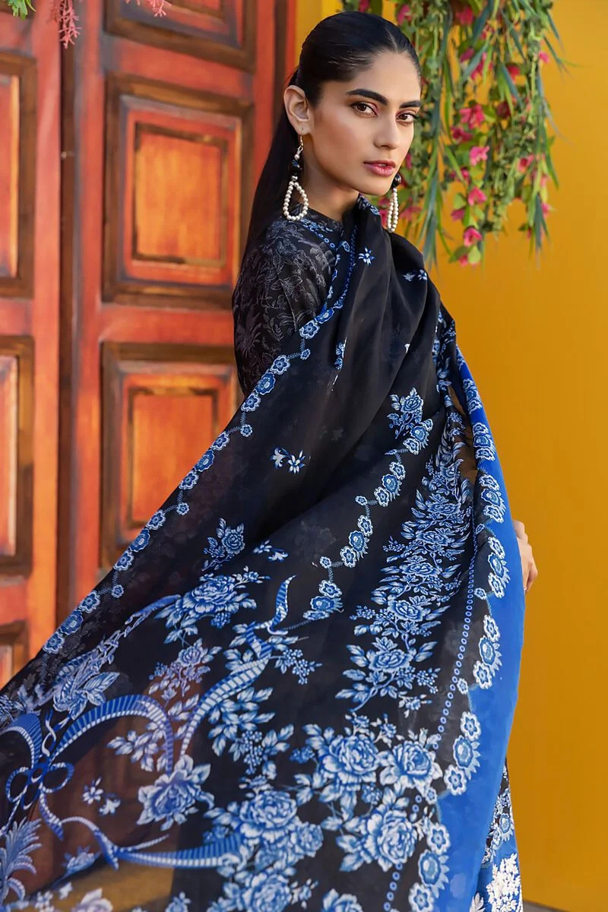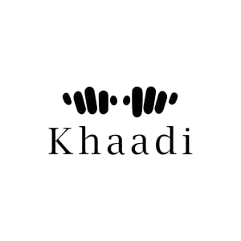

Completing the ensemble is the dupatta, a long scarf that is draped over the shoulders or around the neck. It adds an elegant touch to the outfit and can be used for both style and practical purposes. The dupatta can also feature matching prints or contrasting designs, enhancing the overall aesthetic appeal.

The three-piece dress you described, with its blue color and printed shirt in lawn fabric, represents a fusion of traditional and contemporary elements. It showcases the vibrant and diverse fashion culture of Pakistan, where traditional attire meets modern trends.

* **Details**
  + **Top Fabric:** Printed Lawn | Length 1.75m | Width 58in
  + **Bottom Fabric:** Dyed Cambric | Length 1.7m | Width 58in
  + **Dupatta Fabric:** Printed Lawn | 2.5m
  + **Campaign:** The Print Story